**PREFACE - IMPORTANT**

Parts of this **fictional** operation will present **heavy** themes that are **loosely based on** and mirror real events that took place in Rwanda on April 22 1995. During the *Kibeho Massacre*, as part of United Nations Assistance Mission for Rwanda (UNAMIR), ADF peacekeeping personnel were unable to stop the active killing and torture of internally displaced civilians due to strict Rules of Engagement (ROE). Despite witnessing atrocities, and being under fire, they did their best to provide aid to those they could  
**without firing a shot**.

**This page was intentionally left blank.**

ACTION HUNTING DARK

OPORD

Operation Kujari Stabilisation

Friday, April 11th 2008



Please be nice to me

**1. TASK ORGANISATION 6**

**2. Situation 7**

a) Area of Operations 7

i) Terrain 8

ii) Weather 9

b) Areas of Interest 9

c) Enemy Forces 10

i) Composition, Disposition, and Strength 10

ii) Recent activities 10

iii) Enemy COAs 10

d) Friendly Forces 11

i) Higher HQ Mission and Intent 11

ii) Mission of Adjacent Units 11

e) Attachments and Detachments 11

f) Civil Considerations 12

**3. Mission 12**

**4. Execution 12**

a) Commander’s Intent 12

b) Concept of Operations 13

i) Manoeuvre 13

ii) Fires 13

iii) Reconnaissance and Surveillance 13

iv) Intelligence 14

c) Scheme of Movement and Manoeuvres 14

i) Conduction of Checkpoint Actions 14

iii) Consolidation Phase 15

iv) Phase 1 15

v) Phase 2 16

d) Casualty Evacuation 17

e) Coordinating Instructions 18

i) Time or Coordination 18

ii) Rules of Engagement 18

**5. Sustainment 19**

a) Logistics 19

i) Transportation 19

ii) Supply 19

b) Army Health System Support 19

i) Medical Treatment 19

**6. Command and Control 20**

a) Signal 20

i) SOI Index in Effect 20

ii) Pyrotechnics and Signals 20

**7. UN Specific Instructions 22**

**8. Glossary 22**

# TASK ORGANISATION

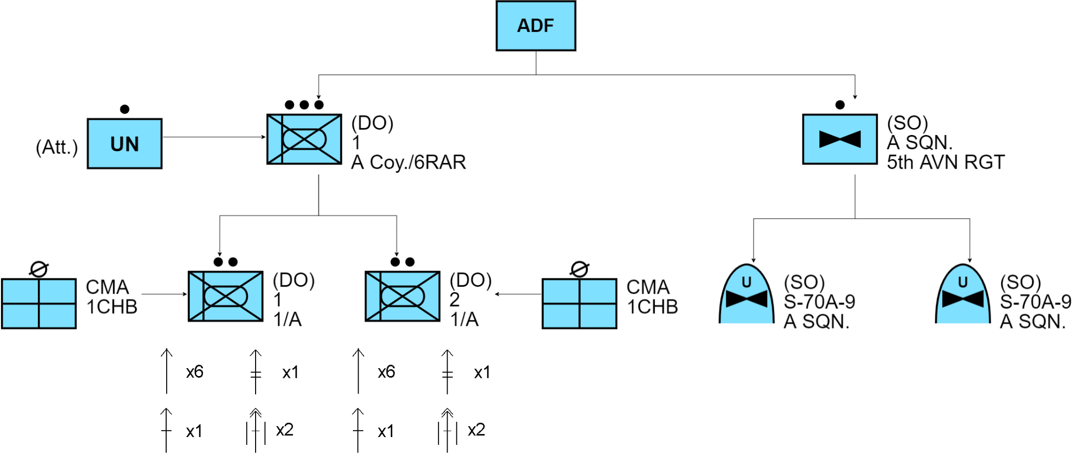

* 7th Brigade, 2nd Division, ADF | Callsign “EMU”
  + **1st Platoon, A Company, 6RAR - (DO)**
    - *1st Section, 1st Platoon, A Company* ***|*** *Callsign “SPEAR 1–1”*
    - *2nd Section, 1st Platoon, A Company* ***|*** *Callsign “SPEAR 1–2”*
    - *2x Combat Medical Attendant - 1 Close Health Battalion (Att)*
  + **16th Aviation Brigade, 5th Aviation Regiment - (SO)**
    - *2x S-70A-9, A Squadron | Callsign “MAGPIE 1 & 2”*
* UN Aid Forces
  + **UN Checkpoint Aid Force**
    - *2x UN Interpreters (French Detachment) (Att) | Callsign “Fortune”*

*All times used in the document are local time (GMT+1) unless stated otherwise.*

# Situation

## Area of Operations

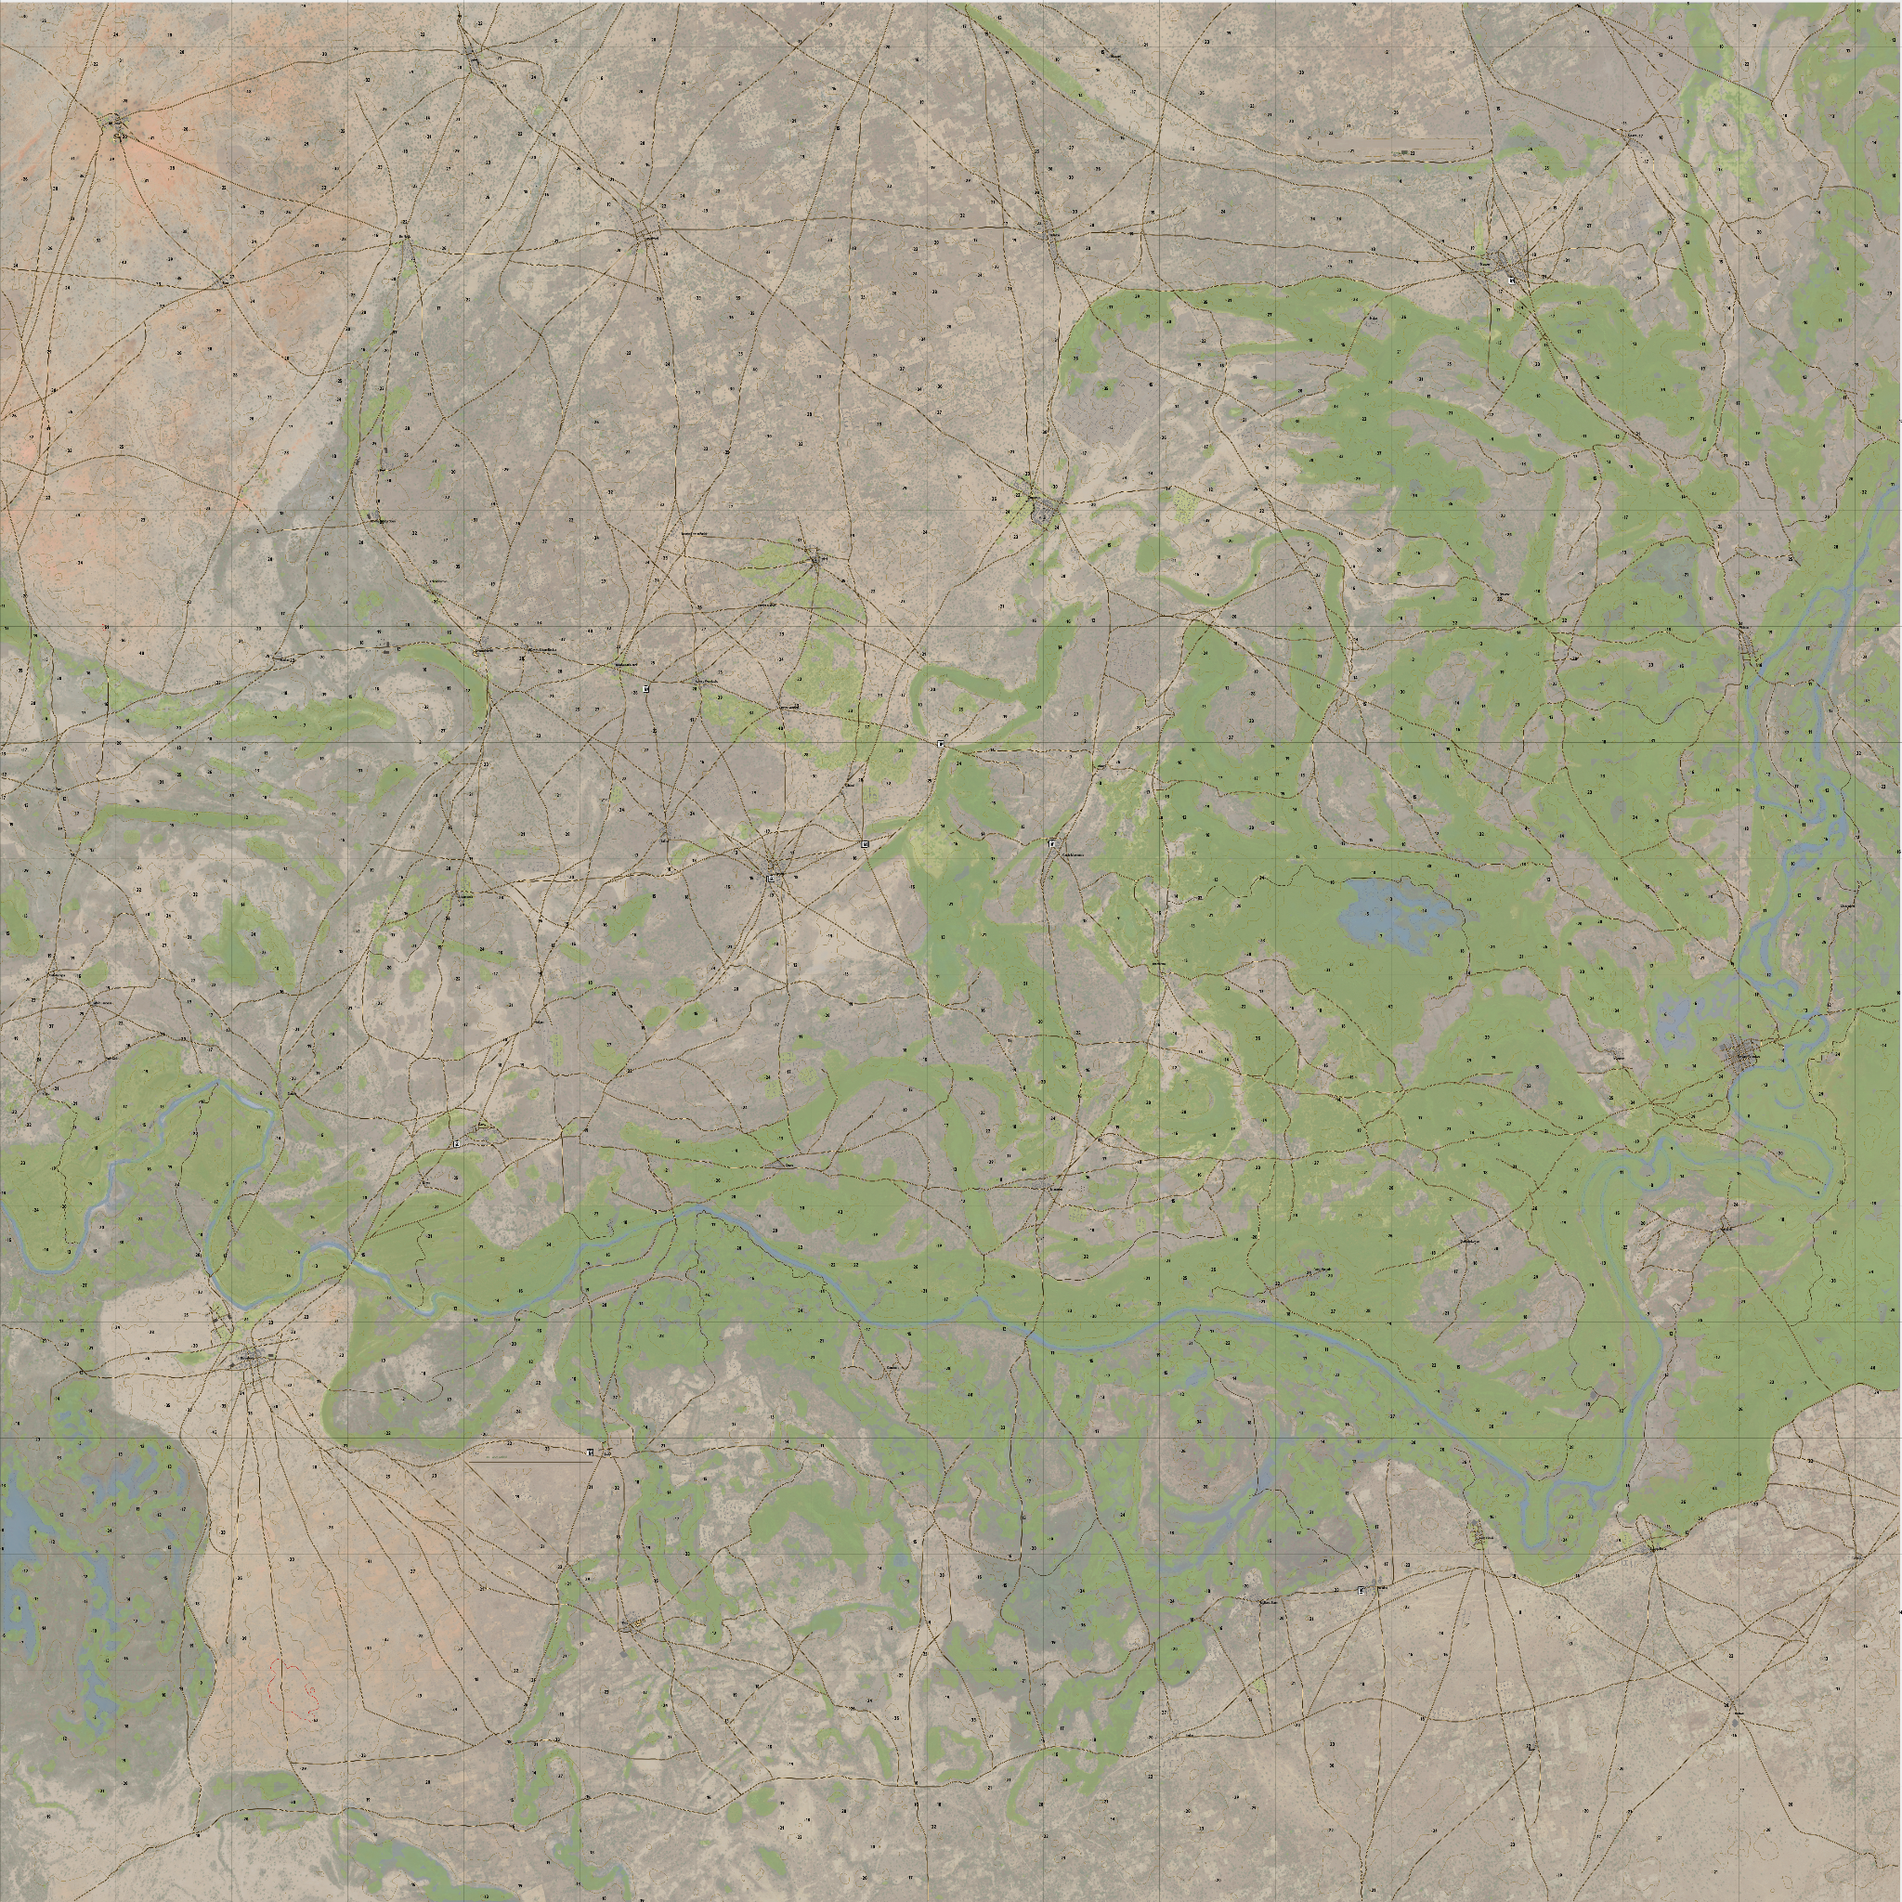  
Kujari -<https://jetelain.github.io/Arma3Map/kujari.html> 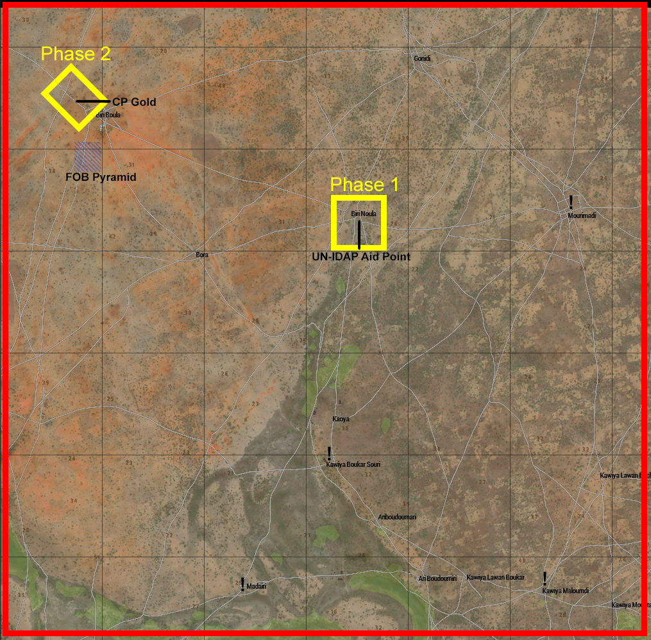  
Area of Operations

### Terrain

The North-West of Kujari for the most part is not densely vegetated compared to the Eastern side of the nation, with trees scattered across the terrain. However, there are large, more concentrated patches of vegetation. Densely populated villages are often located inside these more densely vegetated areas.

The landscape consists of many small hills, with a consistent low elevation. The valleys between hills provide pockets of dead-space that may be used for cover or concealment. Plots of rock formations are consistent over the terrain that often limit movement of vehicles when travelling off-road. These rocks should be taken into consideration when determining movement for mounted units.

The vast majority of the North-Western region is farmland, meaning the likelihood of encountering farm animals like cattle or boar is highly likely. Due to the region being primarily farmland, many animals are accustomed to human contact. Animals may not give way to vehicles or foot traffic, and may instead continue their path unfazed. This creates a necessity to avoid the wildlife if at all possible, and move around them if not. If contact with wildlife occurs personnel are instructed **NOT**to fire at wildlife, but instead attempt to redirect troop movements to avoid them if possible.

### Weather

The forecast for the time of operations is a 90% chance of rain in the early morning, lowering to 70% for the majority of the day. It is expected to be overcast and 92% humidity at a temperature of 34℃. Weather is not expected to limit visibility in any significant way.

High heat and humidity makes it necessary for each individual soldier to carry a **minimum** of 4.5L of water on their person, as well as additional water supplies in vehicles.

## Areas of Interest

* 1. **CP Gold**

ADF Checkpoint North of the village of Biri Boula, used primarily to halt the importation of insurgency enabling items.

* 1. **FOB Pyramid**

Forward Operating Base for the ADF in the North-Western region of Kujari. Located to the South of the village of Biri Boula.

* 1. **Bora**

Medium-sized village South-East of FOB Pyramid. Recently the target of KNFA civilian attack.

* 1. **Biri Noula**

Medium-sized village currently hosting joint UN-IDAP Aid station for internally displaced civilians.

* 1. **Mourimadi**

Large farming village, suspected location for KNFA cache.

* 1. **Biri Boula**

Large village located between FOB Pyramid and CP Gold in the North-West of Kujari.

* 1. **Kawiya Boukar Souri**

Small village, suspected location for KNFA cache.

* 1. **Kawiya Maloumdi**

Medium-sized farming village, suspected location for KNFA cache.

* 1. **Madairi**

Small village, suspected location for KNFA cache.

## Enemy Forces

### Composition, Disposition, and Strength

The defeat of ADF forces at Geydam-Tchoukou have resulted in yet another increase in the strength of the KNFA. The counter-attack caused a loss in confidence in peacekeeping forces allowing the KNFA to leverage recruiting in surrounding areas, as well as the forced induction of fighters in occupied villages. The estimated number of KNFA fighters in Kujari has risen to 6000 from the previous 4200 in the span of one week.

The recruitment around Geydam-Tchoukou has resulted in a concentration of enemy forces in the South-East, as well as the pre-established strength in the North-West.

### Recent activities

After the recent major counterattack on Geydam-Tchoukou, resulting in the **partial-mission failure** of 6RAR’s **Action Hope-Prevail**, activity of KNFA has increased dramatically throughout the entire country. Although mortar attacks have diminished in frequency due to the efforts of D Company, 6RAR, to seek out and close with known mortar cells of the KNFA.

Because of the destruction and confiscation of mortar weapon-systems by D Company, the KNFA have increased efforts to smuggle and import contraband across the North-Eastern border of Kujari. This has resulted in increased security at Checkpoint Gold (CP Gold).

CP Gold has also noted an increase in the trafficking of narcotics, counterfeit and foreign moneys, as well as the increase of use of fake Kujari National Registration Cards (NRC) by smugglers and traffickers. Unfortunately the circulation of the fake NRCs for years has resulted in them being in the possession of civilians without their knowledge.

Reports from UN emplacements around the country have reported an extreme increase in violence towards civilians, including targeted group attacks against entire villages of civilians, beginning to edge on the scale of genocide. On April 9th, KNFA sympathisers conducted a large-scale planned attack on the village of Bora, killing an estimated 150 civilians. UN representatives are concerned about the possibility of a larger scale second attack on the village, and as a result have internally displaced several small villages to the village of Bin Noula where an aid station is situated.

### Enemy COAs

Enemy forces have focused a majority of their actions against civilian populace in recent days, drawing focus away from ADF and UN peacekeeping forces. ADF peacekeeping forces have not reported being under direct fire since April 4th. It is assumed that hostilities against civilians will continue, with little violence against friendly forces unless directly provoked.

Recent analysis of KNFA actions has provided evidence that all civilians are evicted from areas where KNFA conduct insurgency related activities (i.e. storage of contraband, training of units, housing of personnel)

## Friendly Forces

### Higher HQ Mission and Intent

7th Brigade has prioritised the confiscation and destruction of militia enabling contraband such as narcotics and weapons systems through decisive operations. These operations consist of halting the importing and exporting of prohibited goods at checkpoints, and the direct seeking and destruction of stores and cells within the country. This aims to hinder the abilities of the insurgency by restricting their access to key equipment.

### Mission of Adjacent Units

At the time of this action, 3rd Platoon of D Coy, 6RAR, callsign “*UNCLE*” will be tasked with a reconnaissance foot patrol around the border of Mourimadi. The intent for this patrol is to locate KNFA emplacements suspected in the involvement of the recent killing at the village of Bora.

2/14th LHR (QMI) and 2CER continue to occupy PB Platypus in the South-East of Kujari in attempts to reconsolidate the supply of aid in the capital of Geydam-Tchoukou.

At the time of being relieved at CP Gold; 2 Platoon, A Coy., 6RAR; callsign “*CABLE*” will move to the village of Bora to aid in the casualty collection of civilians. At the time of completion of this task, or when otherwise instructed, 2 platoon will again relieve 1 platoon of checkpoint duties at CP Gold.

## Attachments and Detachments

| Unit | Attachment |
| --- | --- |
| 6RAR Platoon | 2x 1CHB Combat Medical Attendants |
| 6RAR Platoon | Eastern Post News Journalist |
| 6RAR Platoon | 2x French UN Interpreters |

## 

## Civil Considerations

The villages directly surrounding FOB Pyramid and CP Gold are all civilian occupied. Compared to the rest of the country, civilians in the North-West of the country are generally less hostile towards peacekeeping forces due to positive efforts from the UN and ADF.

Because of the recent internal displacement of civilians after mass killings by the KNFA, there is a higher density of civilians in Biri Noula, seeking aid from the UN-IDAP joint aid station in the village. The concentration of persons in the small village has resulted in overcrowding in areas immediately surrounding the village, causing concern for injury as civilians from other villages are continuing to seek aid at the station.

# Mission

At 0615 hours, 1 platoon from A Coy. 6RAR, callsign “*SPEAR*” will provide self-transport via Bushmaster PMV-Ms along the designated route to the village of Biri Noula in attempts to provide security to the delivery of aid supplies to the UN-IDAP joint aid station. During this time 2 S-70A-9 blackhawk helicopters, callsign “*MAGPIE*”, will provide flyover surveillance for the platoon. At the completion of the supply delivery, providing adequate security has been established, the platoon will return to FOB Pyramid for any required resupply, before proceeding to CP Gold to relieve 2 platoon for checkpoint processing operations.

*SPEAR* will continue checkpoint operations while *MAGPIE* conducts aerial reconnaissance around designated areas for suspected stores of insurgent contraband such as narcotics, training equipment, or weapons systems. If *MAGPIE* locates such caches, *SPEAR* will be relieved by *CABLE*, and return to FOB Pyramid for staging. At the time of *SPEAR* returning to FOB Pyramid, *MAGPIE* will also return to FOB Pyramid to provide transportation to the identified cache for documentation and confiscation.

# Execution

## Commander’s Intent

The primary intent of Action Hunting Dark is to limit or completely halt the importation of items and equipment that aid the insurgency of the KNFA. Supporting this is the location, documentation, and destruction of a suspected primary cache of this equipment within the North-West of the nation.

Success will be decided by the provision of security to UN-IDAP aid personnel at the UN-IDAP aid point, successful provision of security, and preventing the passing of dangerous individuals to CP Gold, and the location, documentation, and destruction of the suspected KNFA cache.

## Concept of Operations

### Manoeuvre

*SPEAR* platoon has their 4x assigned BUSHMASTER PMV-Ms to provide self transport to and from Phase 1 of operations. The configuration of PMV-Ms are 2x Transport and Command (T&C) configured vehicles, and 2x Mounted Weapon Systems (MWS) configured vehicles. The MWS vehicles are equipped with 12.7 Millimetre M2 guns. Due to restrictions the BUSHMASTER vehicles are not equipped with purpose built radios, and instead personal radios will be used.

In the event that forces undertake Phase 3 of operations, callsign *MAGPIE* will provide aerial transport of troops to the target location via their S-70A-9 Blackhawks. These vehicles will remain on tasking for CASEVAC and EXFIL transportation.

### Fires

The fire elements in possession of each element are as follows.

* 1st Section, 1PLT, A Coy, 6RAR:
  + 2x Bushmaster PMV-M
  + 6x F88 Rifles
  + 1x F89 Light Support Weapon
  + 1x MAG58 Medium Support Weapon
  + 1x M72 Light Anti-tank Weapon (LAW)
* 1st Section, 1PLT, A Coy, 6RAR:
  + 2x Bushmaster PMV-M
  + 6x F88 Rifles
  + 1x F89 Light Support Weapon
  + 1x MAG58 Medium Support Weapon
  + 1x M72 Light Anti-tank Weapon (LAW)
* A Sqn, 5th Avn Regt:
  + 2x S-70A-9 Blackhawks
  + 4x F88 Rifles

FSA and CAS will be unavailable for tasking for the duration of this operation.

### Reconnaissance and Surveillance

*UNCLE* will be on reconnaissance patrols in the vicinity of Mourimadi during the phases of this action. Additionally, *MAGPIE*’s tasking doubles as surveillance over ground unit operations due to proximity of tasking.

### Intelligence

Intelligence operations conducted prior to the operation have indicated that there is a KNFA cache being stored in the North-West region of the nation, in moderate proximity to FOB Pyramid and CP Gold. The storage of insurgency enabling equipment within short range to ADF emplacements causes concern for attack.

## Scheme of Movement and Manoeuvres

### **Conduction of Checkpoint Actions**

### 

CP Gold requires a minimum of one personnel at either gate at all times, to operate the gate and instruct approaching persons. In addition to this it is required that a minimum of one person is required in the vehicle and person search area for searching. Suspicious persons must be searched and if deemed a threat, detained and placed in the person detention centre on the opposite side of CP Gold. Both the search and detention areas are separated for male and female sections.

Confiscated items are to be placed in the supplied bins next to the person search area. Once rendered safe, vehicles left by detained persons are to be moved outside of the checkpoint to a safe distance.

Platoon and section leaders are responsible for the planning and positioning of units within the checkpoints during their rotational duty at the checkpoint. Units are permitted to fire 1 (one) warning shot in front of approaching vehicles to intimidate persons that are suspected of causing damage to the checkpoint, or harming persons inside.

After firing a warning shot vehicles or persons may be engaged if they:

1. Approach at a high range of speed with refusal to stop,

OR

1. Indicate intent to immediately give harm to friendly persons, vehicles, or buildings via explosives, firearms, or other means

OR

1. A vehicle or person continues to advance past a designated point, whilst not complying with given instructions
   * 1. **UN Requirements**

Whenever ADF forces are tasked with representing the UN, or on missions directly providing support to UN activities, personnel are required to wear appropriate headwear in accordance with Army Dress Manual Chapter 3. Headwear is to be blue in colour and have the UN flash in appropriate positioning.

Rules of engagement are also restricted when representing, or supporting UN operations. For more information refer to Section 4, Subsection E (ii) - Rules of Engagement

### **Consolidation Phase**

Before conducting the initial phase of operations, ground forces will consolidate and prepare at FOB Pyramid at 0530 hours in front of the FOB’s TOC (tactical operations centre). This phase aims to provide sufficient time for checking of equipment, testing of communications, preparation of vehicles and weapons systems, and dissemination of key information in the form of platoon and section briefs. At the completion of this phase, immediately before stepping off, ground units will move and organise vehicles on the road outside of FOB Pyramid, and inform appropriate channels of movements.

### **Phase 1**

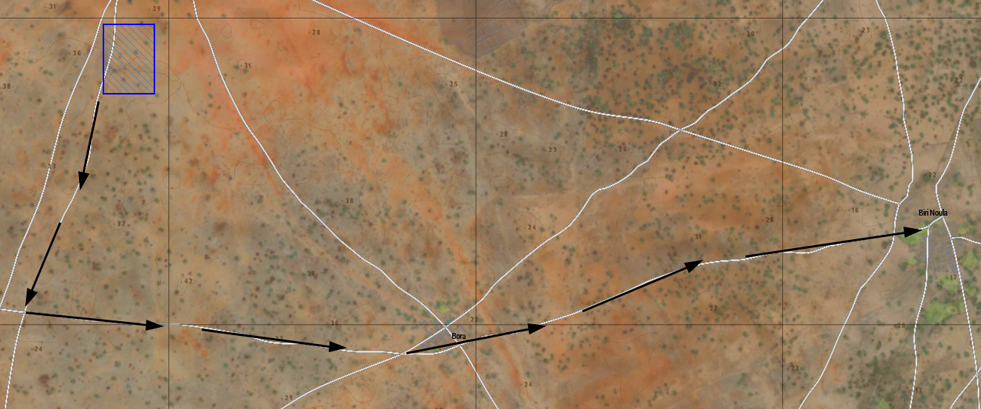  
Phase 1 Movement

2 sections from 1 Platoon, A Coy., 6RAR, callsign *SPEAR*, will mount their assigned BUSHMASTER protected mobility vehicles, and depart FOB Pyramid NLT 0615 hours towards the village of Biri Noula southwards via the road on the West side of the FOB, before turning and travelling East towards the village. Upon reaching the village, forces will move to the UN-IDAP aid station, and stage their vehicles in appropriate places so as not to block access to the aid station by civilians.

Units will then disembark vehicles to provide security to UN and IDAP personnel until the time a delivery of aid supplies arrives from Goridi by IDAP personnel. The aim of this security detail is to prevent violence against UN or IDAP personnel by either angry civilians or KNFA insurgents. Due to agreements for relations when working with IDAP and the UN, it is imperative that ROEs are strictly adhered to.

During this phase, aircraft of callsign *MAGPIE* are tasked with flyover escort during the transportation of the phase, before remaining on station for emergency tasking.

Whereafter the delivery of aid supplies has been completed, and security forces are satisfied with the current situation of the immediate area, *SPEAR* will re-mount vehicles and return to FOB Pyramid along the same route they arrived on for rearm and resupply, before executing Phase 2 of operations.

### **Phase 2**

At the completion of Phase 1, and after resupplying at FOB Pyramid, 1 Platoon is tasked with relieving 2 platoon for checkpoint duties at CP Gold. *SPEAR* will remain at CP Gold until the time 2 platoon, callsign *CABLE* has finished casualty collection in the village of Bora. At this time *CABLE* will relieve *SPEAR* at CP Gold, and *SPEAR* will return to FOB Pyramid for additional rearm/resupply.

During this phase of operations, *MAGPIE* will conduct flyovers of POIs in attempts to locate a suspected KNFA cache. The POIs in order of precedence are as follows:

* Madairi
* Mourimadi
* Kawiya Maloumdi
* Kawiya Boukar Souri

Although *MAGPIE* is tasked with this search tasking, their priority is any logistical and/or security assistance required by *SPEAR* at CP Gold such as reconnaissance flyovers or perimeter security checks.

* + 1. **Phase 3**

In the event that *MAGPIE* locates the suspected KNFA cache during its flyover tasking, they are to report its position on the designated command channel. Because the exact location of the cache is unknown, forces must coordinate plans with each other as forces move forward, this includes designation of HLZs, CCPs, and rally points, and courses of action.

*SPEAR* will then prepare for Phase 3 of operations at FOB Pyramid before calling a MOVEREQ on the designated air transport net. At this time, *MAGPIE* will return to FOB Pyramid to pick up and provide transport to *SPEAR*’s designated landing zone. *MAGPIE* will remain on station and in the area for the duration of this phase to provide ISR to ground units, and emergency transport, provided the logistics allow.

*SPEAR* is to document the location, size, and contents of the cache at arrival, as well as clearing the immediate area of civilians and providing security while explosives are prepared for the destruction of the cache.

Upon destruction of the cache, *SPEAR* will again make a MOVEREQ to *MAGPIE* to return to FOB Pyramid.

Phase 3 will be marked successful upon the destruction of the cache, and successful EXFIL of all friendly assets.

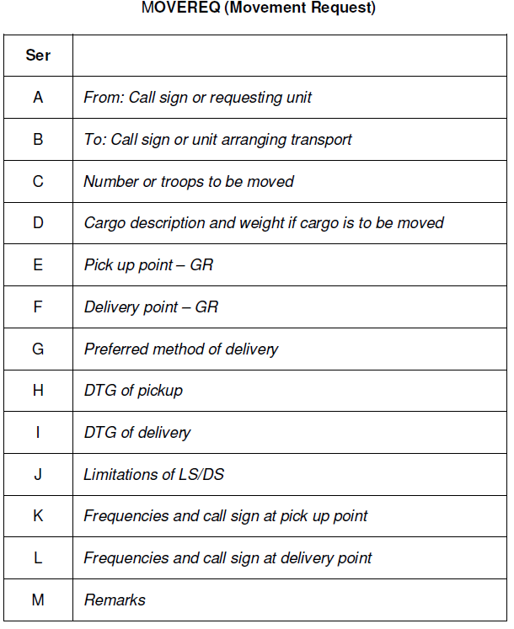

## Casualty Evacuation

The plan for medical and casualty evacuation remains the same through all phases of the action. Non-urgent casualties will be treated to the unit’s best effect and transported back on the same vehicle they were infilled with. Priority 1 casualties (immediate) are permitted for air CASEVAC by callsign *MAGPIE*, providing circumstances allow. Ground units must call for CASEVAC on the designated air transport net before designating a suitable HLZ for the helicopter, and signalling with red smoke.

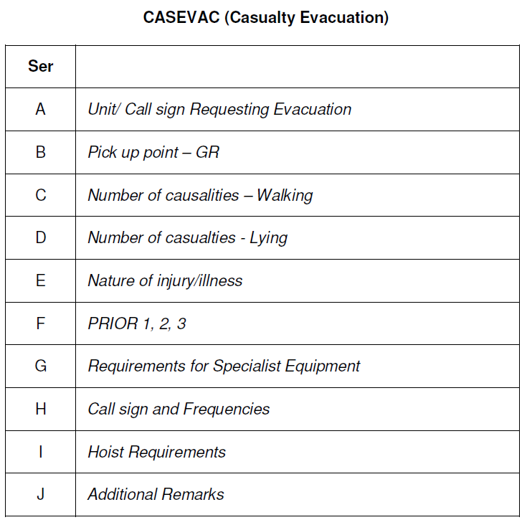

## Coordinating Instructions

### Time or Coordination

Equipment of forces should be organised and units ready for step-off NLT 0615 hours. To ensure this, organisation and preparation will begin as early as 0530 hours. This provides sufficient time allocation to check equipment and weapons systems, conduct command briefs, and disseminate information.

### Rules of Engagement

1. **Phase 1**

Rules of Engagement for Phase 1 of operations are distinctly different from the other two phases of operations. When at UN emplacements, or when representing the UN, ADF forces are strictly prohibited from discharging any weapon system unless any ADF personnel is directly injured as a result of incoming fires.

1. **Phase 2**

In Phase 2 of operations, forces will be stationed at CP Gold, meaning the rules of engagement are highly dependent on the actions of persons passing through the checkpoint. For more details refer to Section 4, Subsection C (i) - Conduction of Checkpoint Actions.

1. **Phase 3**

In the event that forces undertake the third phase of operations, rules of engagement will be less restricted than preceding phases. Units are permitted to return fire in the event that they come under direct fire with hostile intent by opposing forces.

# Sustainment

## Logistics

### Transportation

Transportation of ground units in Phase 1 is self provided by the platoon with assigned BUSHMASTER PMV-Ms. In the event these vehicles become unusable to the extent that all forces cannot be carried inside them, *MAGPIE* will re-prioritise tasking to transportation of *SPEAR* units.

Phase 2 of operations is a stationary phase, meaning it requires no transportation of ground units.

Transportation of ground units in Phase 3 is to be provided by *MAGPIE*’s S-70A-9 Blackhawk helicopters.

### Supply

Each BUSHMASTER vehicle stores sufficient field resupply including ammunition, medical, and signals equipment. The vehicles also contain additional primary weapons systems for ground units and secondary weapons like anti-tank systems. Each BUSHMASTER also contains a medical stretcher for casualty movement.

In the event of supplies being drastically diminished, units may issue an OPDEM, PRIDEM, or MAINTDEM over the designated command net.

## Army Health System Support

### Medical Treatment

There is 1 (one) combat medical attendant (CMA) attached from 1st Close Health Battalion (1CHB) to each section of the platoon. The CMA is in charge of health and casualty triage for their section. The CMA is responsible for their own equipment and medication supplies to provide sufficient care to combatant and noncombatant individuals. New equipment may be provided to sections upon request of the platoon CMA to ensure there is an available readiness. If an individual is injured they should practise SOPs and provide self aid to the best of their abilities.

# Command and Control

## Signal

### SOI Index in Effect

| **Frequency** | **Use** |
| --- | --- |
| 50.000 MHz | SPEAR PLT NET |
| 51.000 MHz | SPEAR 1-1 SECTION NET |
| 52.000 MHz | SPEAR 1-2 SECTION NET |
| 36.720 MHz | AIR TRANSPORT NET |
| 30.000 MHz | COMPANY NET |
| 41.500 MHz | UNCLE PLT NET |

### 

### Pyrotechnics and Signals

Signalling friendly positions, enemy positions, and others will be done primarily with coloured smoke. Blue smoke will signify enemy positions, green smoke will signify friendly positions, purple smoke will signify HLZ positions, and red smoke will signify CASEVAC locations and Casualty Collection Points (CCPs) if necessary.

# 

# 

# 

# 

# 

**This page was intentionally left blank.**

# 

# UN Specific Instructions

The UN has provided specific instructions they have issued to UN personnel attached to ADF units. These instructions primarily advise on checkpoint actions inside CP Gold, and conduct at other ADF instalments such as FOB Pyramid.

The provided instructions are:

1. While inside the boundaries of an ADF emplacement, UN personnel’s primary firearm must remain inside storage such as assigned vehicles or equipment lockers.
2. While inside the boundaries of an ADF emplacement ,UN personnel’s sidearm must remain holstered unless being used in defence of the UN person.
3. UN personnel may carry their primary weapon system when outside the boundaries of ADF emplacements. However, the use of these weapon systems are restricted unless the individual is in immediate danger.

# Glossary

| Noted As | Intended Meaning |
| --- | --- |
| 1CHB | 1st Close Health Battalion |
| 2/14th LHR (QMI) | 2/14th Light Horse Regiment (Queensland Mounted Infantry) |
| 2CER | 2nd Combat Engineer Regiment |
| 6RAR | 6th Battalion, Royal Australian Regiment |
| ADF | Australian Defence Force |
| CAS | Close Air Support |
| CASEVAC | Casualty Evacuation |
| CCP | Casualty Collection Points |
| CMA | Combat Medical Attendant |
| Coy. | Company |
| CP | Checkpoint |
| EXFIL | Exfiltrate |
| FOB | Forward Operating Base |
| FSA | Fire Support Asset |
| HLZ | Helicopter Landing Zone |
| IDAP | International Development & Aid Project |
| ISR | Intelligence, Surveillance, and Reconnaissance |
| KNFA | Kujari National Freedom Army |
| LAW | Light Anti-tank Weapon |
| LOCSTAT | Location Status |
| LSW | Light Support Weapon |
| MAINTDEM | Maintenance Demand (Within 12 Hours) |
| MOVEREQ | Movement Request |
| MSW | Medium Support Weapon |
| MWS | Mounted Weapon System |
| NLT | No Later Than |
| NRC | National Registration Card |
| OPDEM | Operational Demand (Within 3 Hours) |
| PLT | Platoon |
| PMV-M | Protected Mobility Vehicle (Medium) |
| POI | Point(s) of Interest |
| PRIDEM | Primary Demand (Within 6 Hours) |
| ROE | Rule(s) Of Engagement |
| SOI | Signal Operating Instructions |
| SOP | Standard Operating Procedure |
| TOC | Tactical Operations Centre |
| UN | United Nations |